**LEASE MANAGEMENT**

**College Name: Government Arts and Science College For Women, Puliakulam**

**College Code: Brubm**

**TEAM ID:**  NM2025TMID26084

**TEAM MEMBERS:**  04

**Team LeaderName:** Sujithra R

**Email:** suji07489@gmail.com

**Team Member1:** Seethalakshmi M

**Email:** seethalakshmi01102009@gmail.com

**Team Member2:**  Swathika R

**Email:**  swathikarajkamal@gmail.com

**Team Member3:** Thenmozhi A

**Email:** sanjayarockiadass1985@gmail.com

**1.INTRODUCTION**

## 1.1 Project Overview

The Lease Management System is a Salesforce-based application designed to streamline the processes associated with leasing real estate properties. A lease management project provides a structured approach to administering, monitoring, and controlling a company's lease portfolio, encompassing activities from lease initiation to renewal and termination.  It handles tenant management, lease contracts, payments, and communication with automation features such as flows, approval process and email alerts.

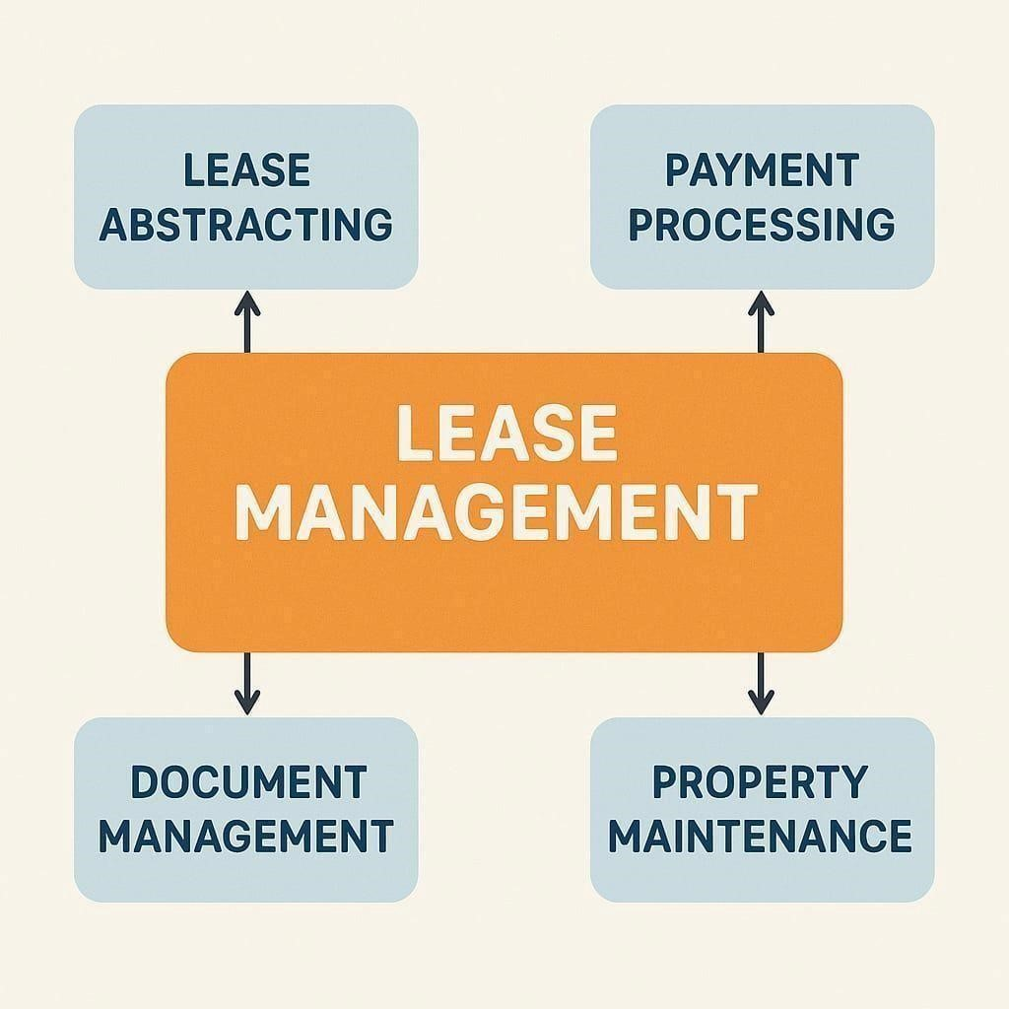

**1.2 Purpose**

The main objective of the project is to enable organizations to efficiently manage properties, tenants, and lease-related activities. It reduces manual intervention, improves accuracy, and ensures better compliance and communication.

# DEVELOPMENT PHASE

**Creating Developer Account:**

By using this URL[**- https://www.salesforce.com/form/developer-signup/?d=pb**](https://www.salesforce.com/form/developer-signup/?d=pb)

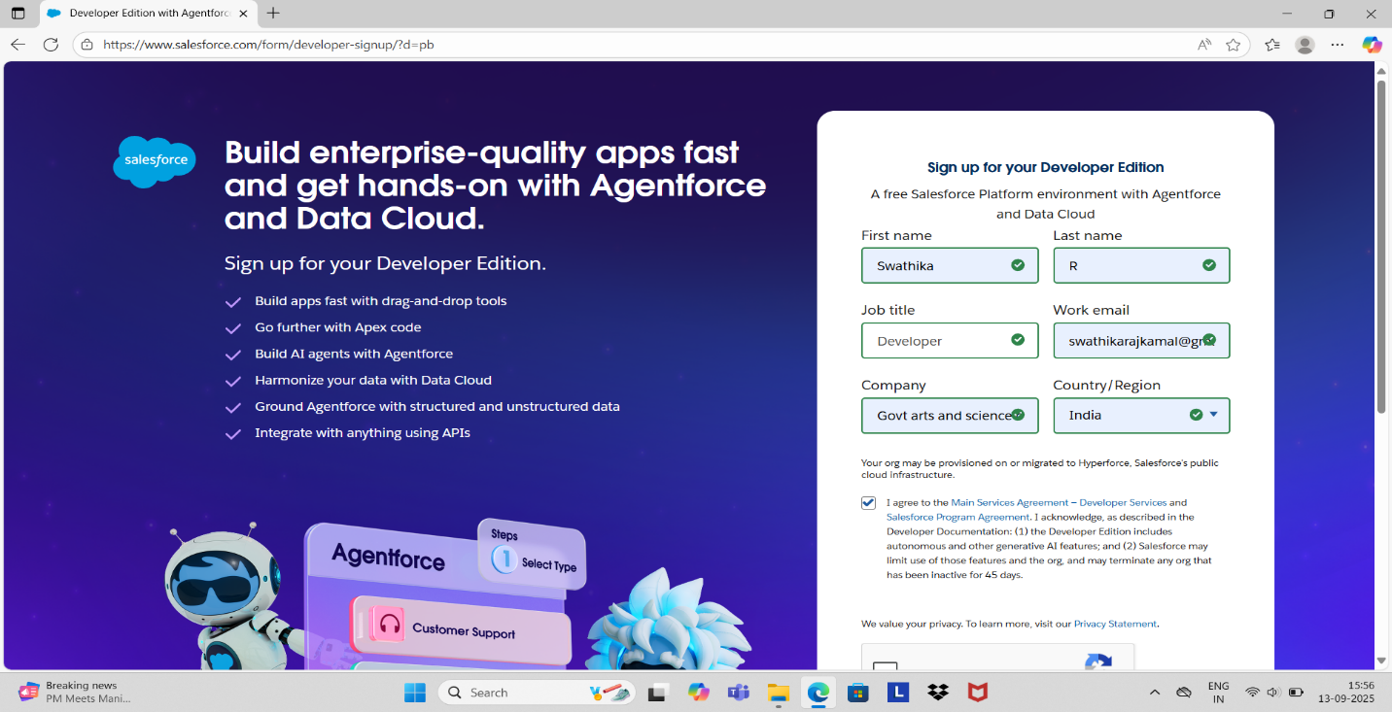

* **Created objects: Property, Tenant, Lease, Payment**

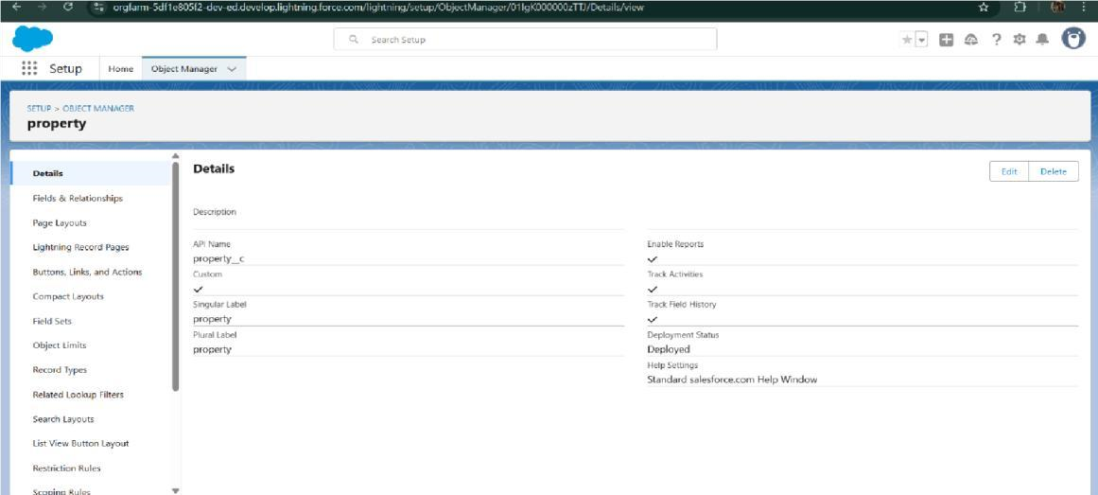

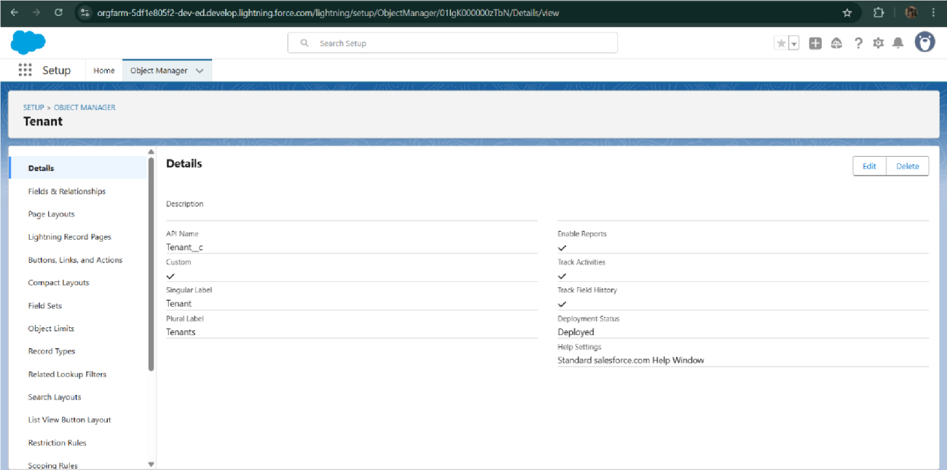

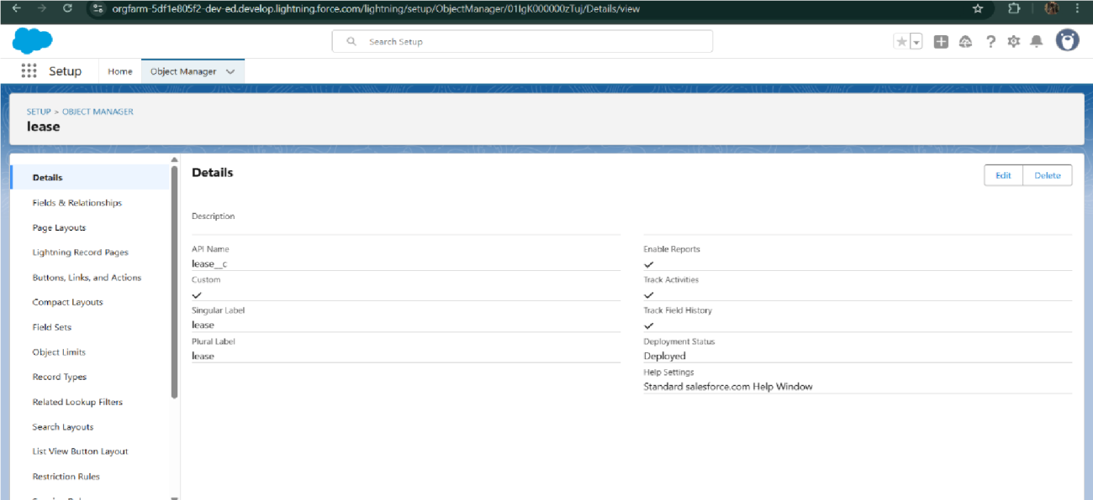

* **Configured fields and relationships**

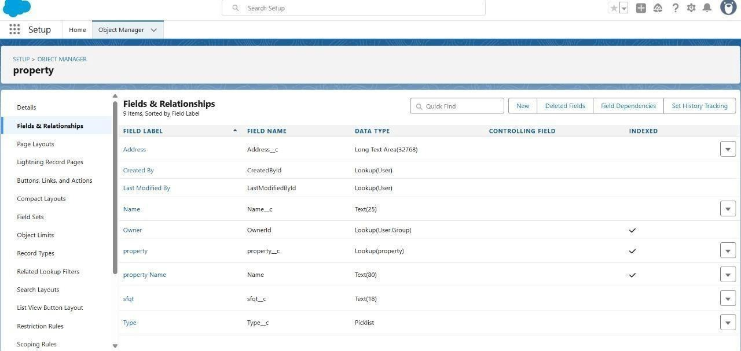

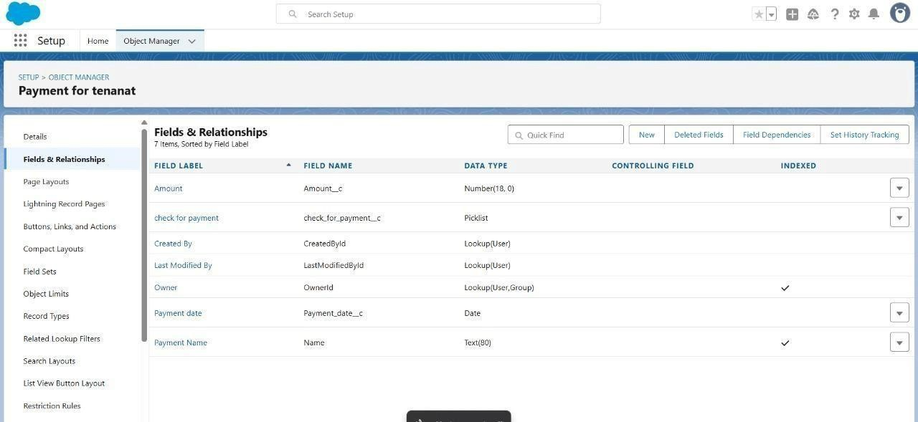

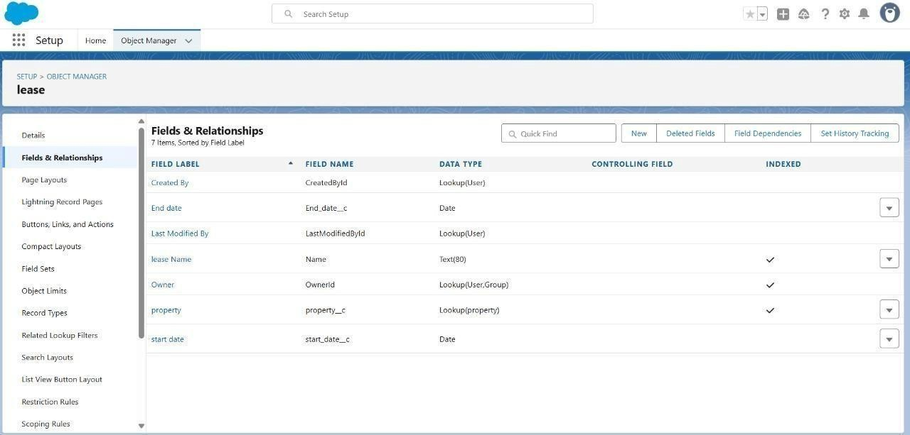

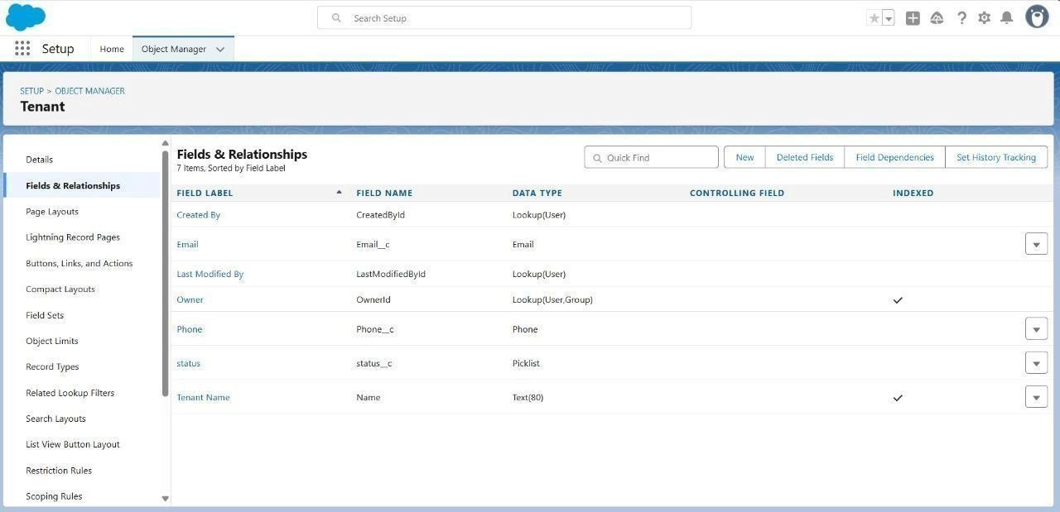

* **Developed Lightning App with relevant tabs**

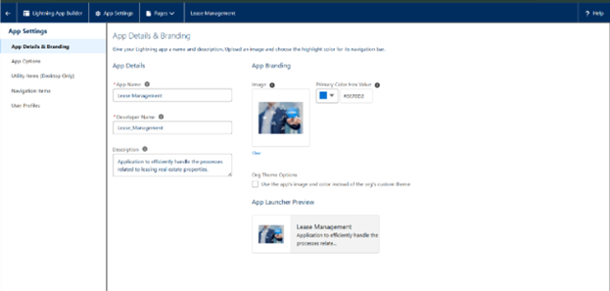

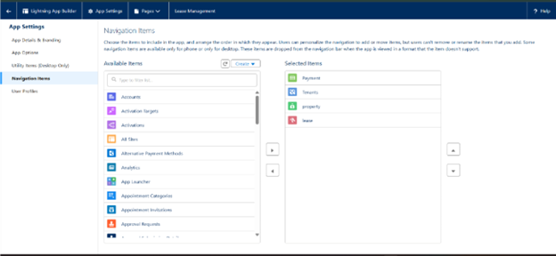

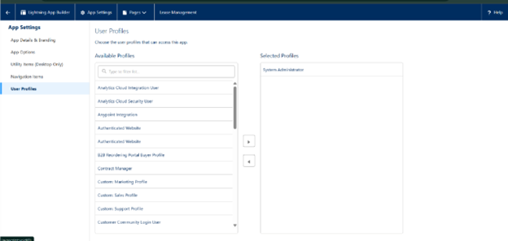

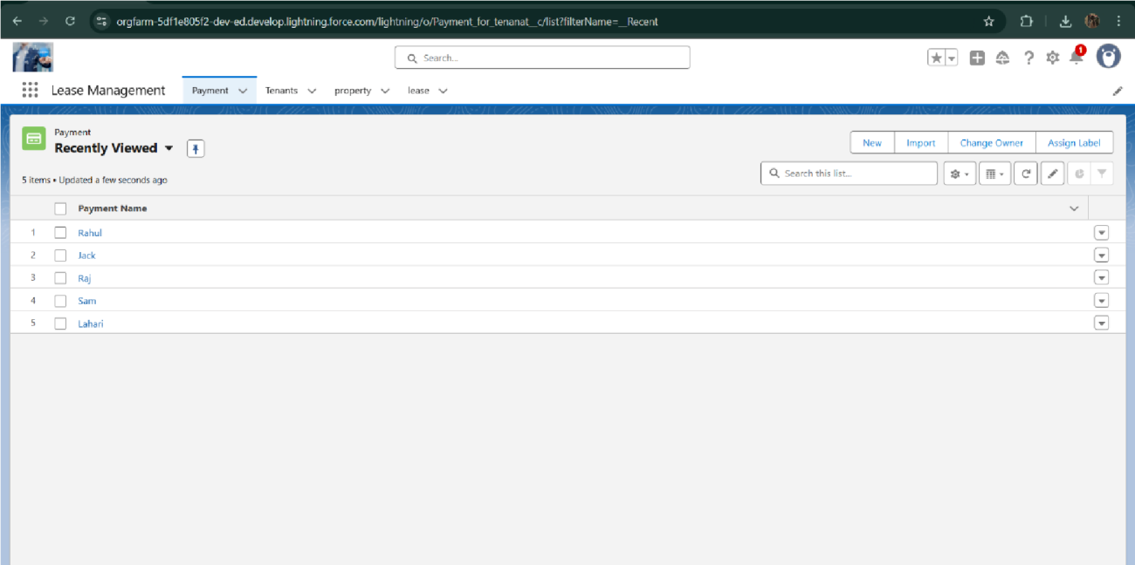

* **Implemented Flows for monthly rent and payment success**

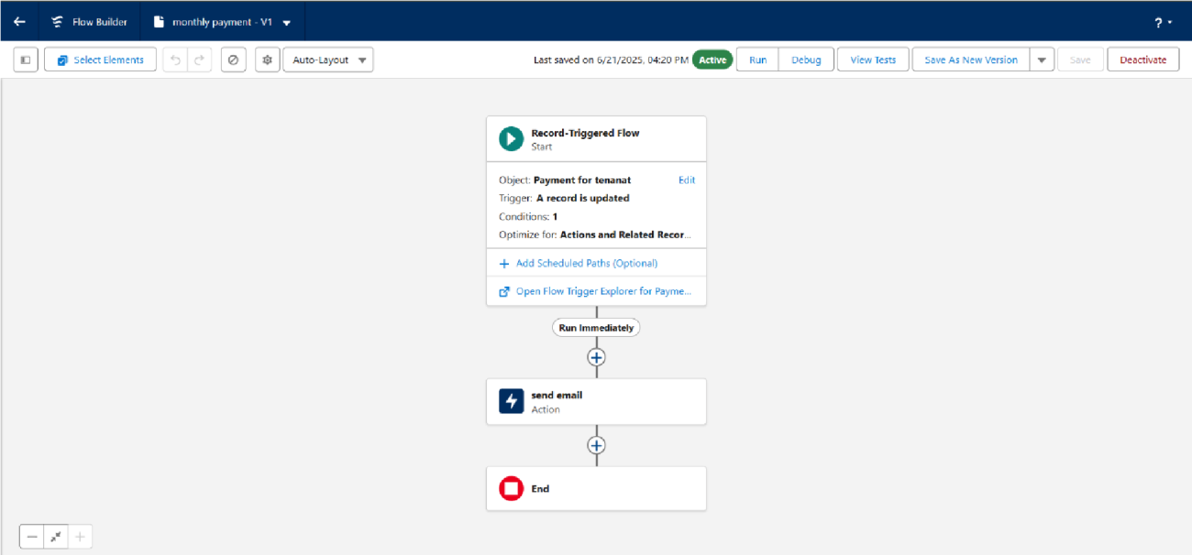

* **To create a validation rule to a Lease Object**

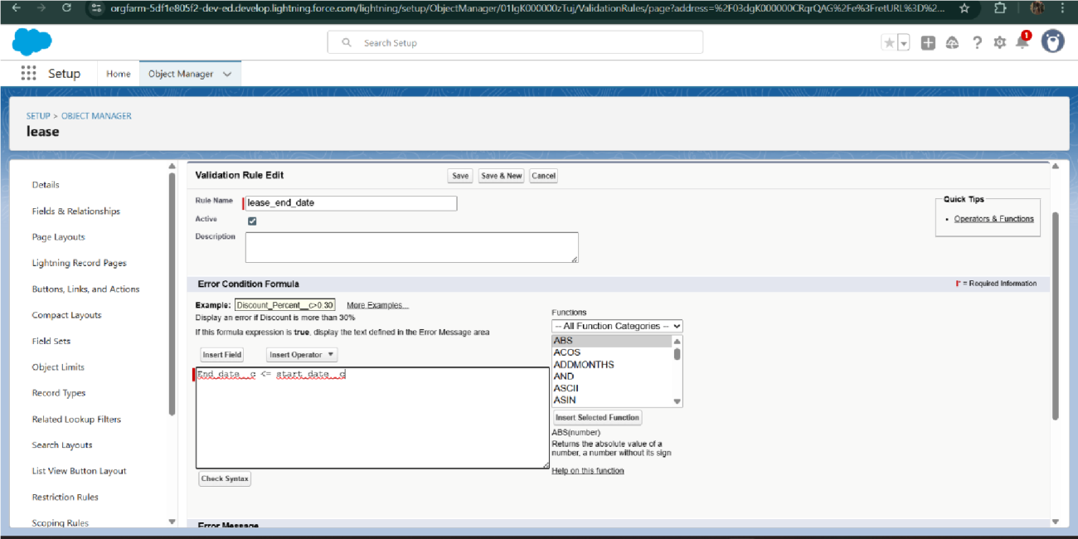

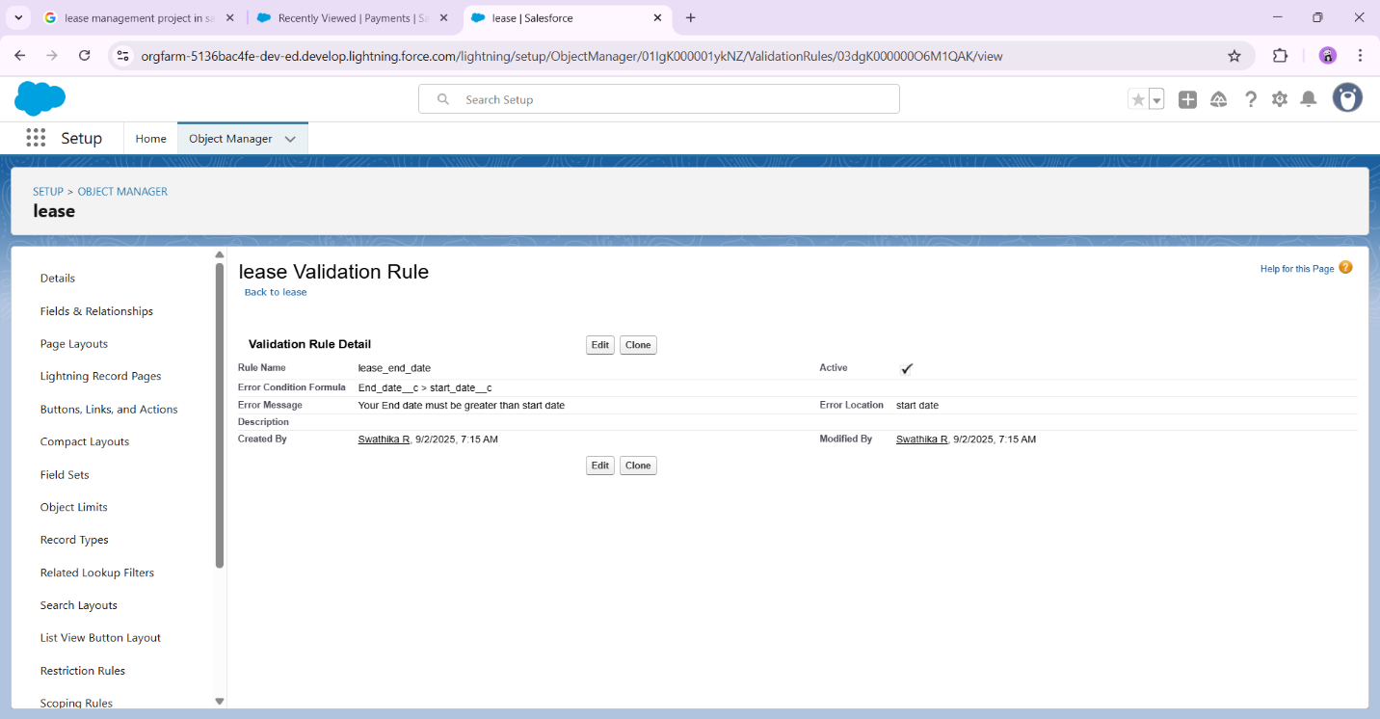

* **Added Apex trigger to restrict multiple tenants per property**

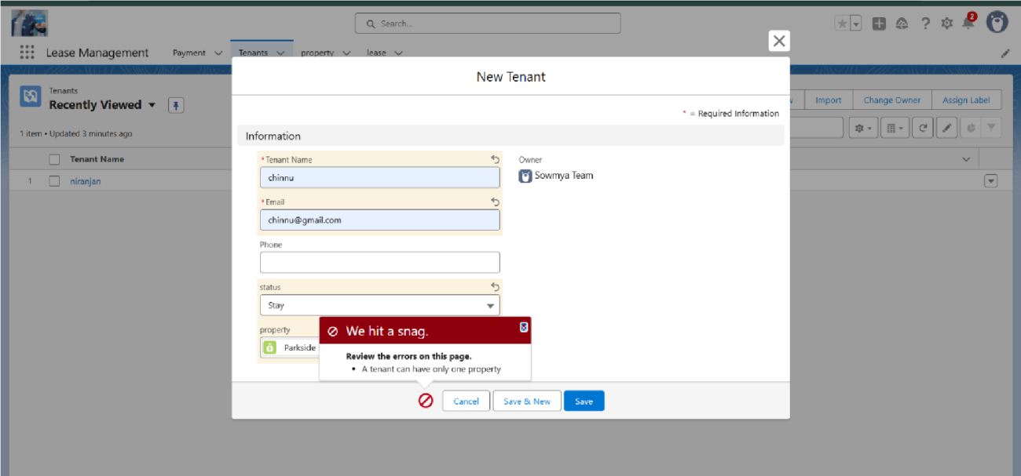

* **Scheduled monthly reminder emails using Apex class**

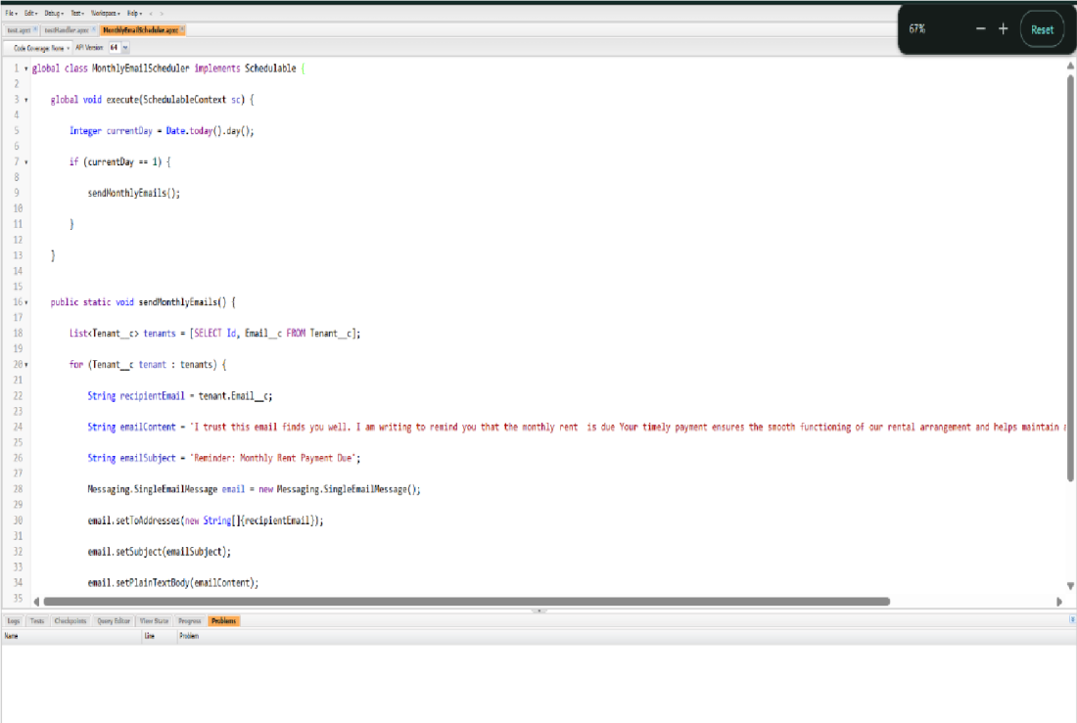

* **Built and tested email templates for leave request, approval, rejection, payment, and reminders**

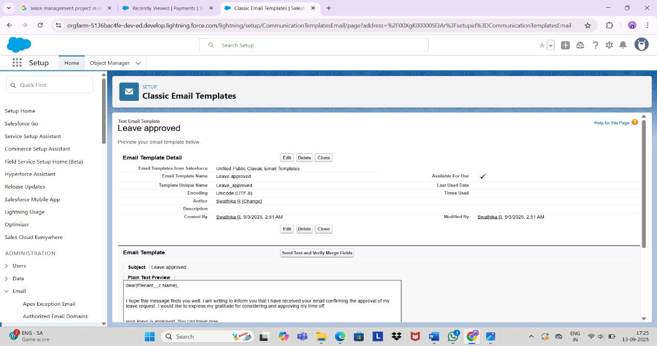

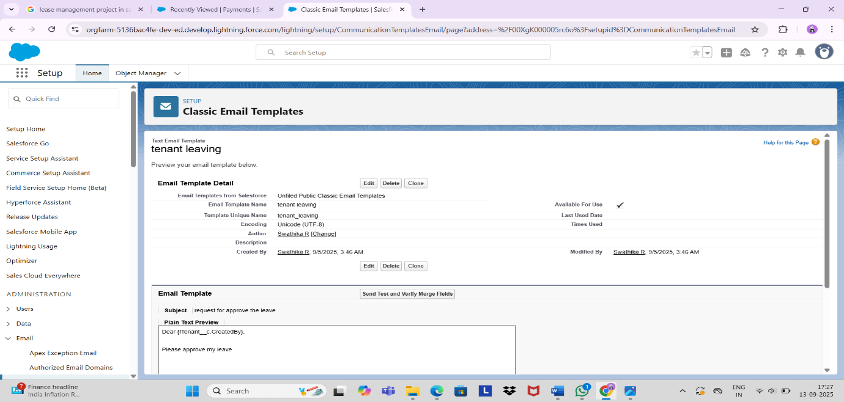

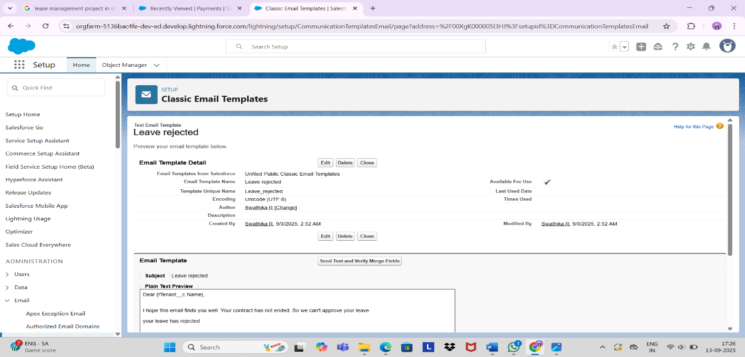

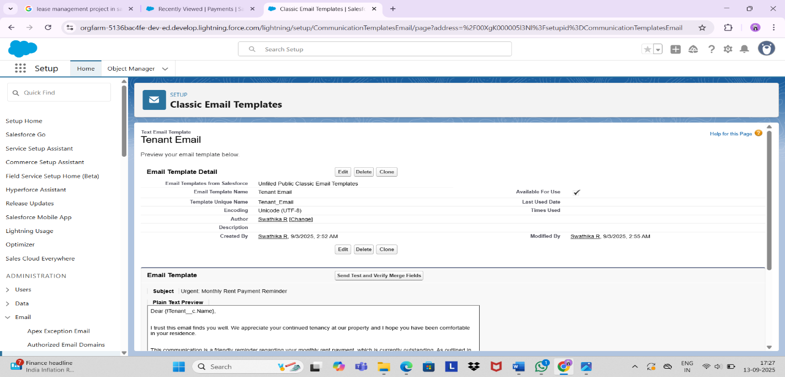

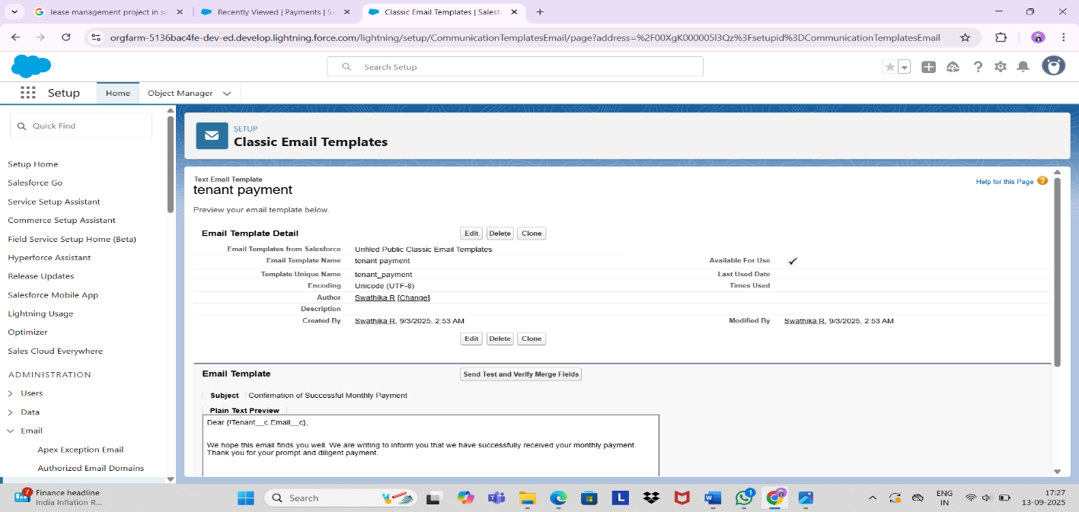

* **Approval Process creation :**

**For Check for Vacant:**

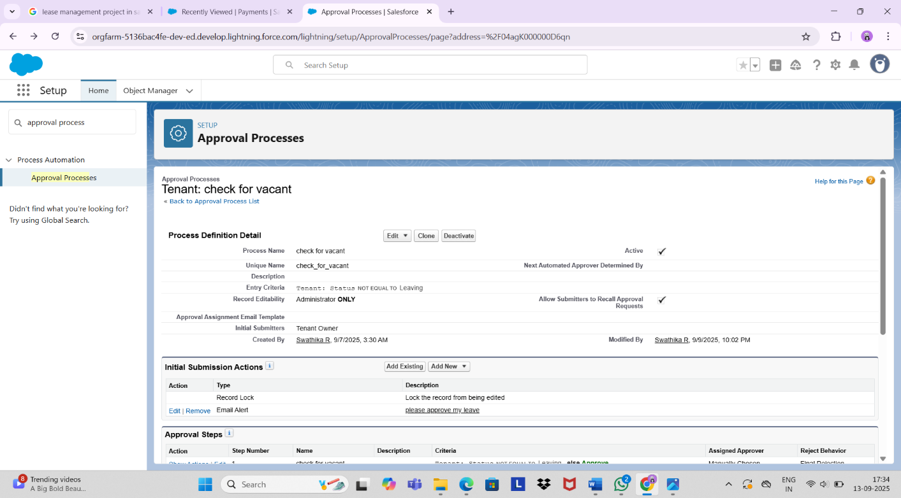

* **Apex Trigger :**

**Create an Apex Trigger**

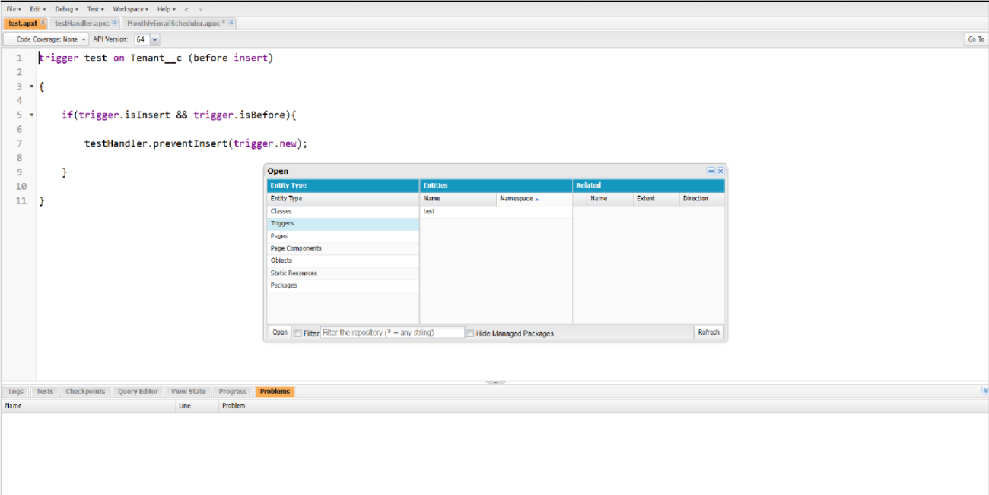

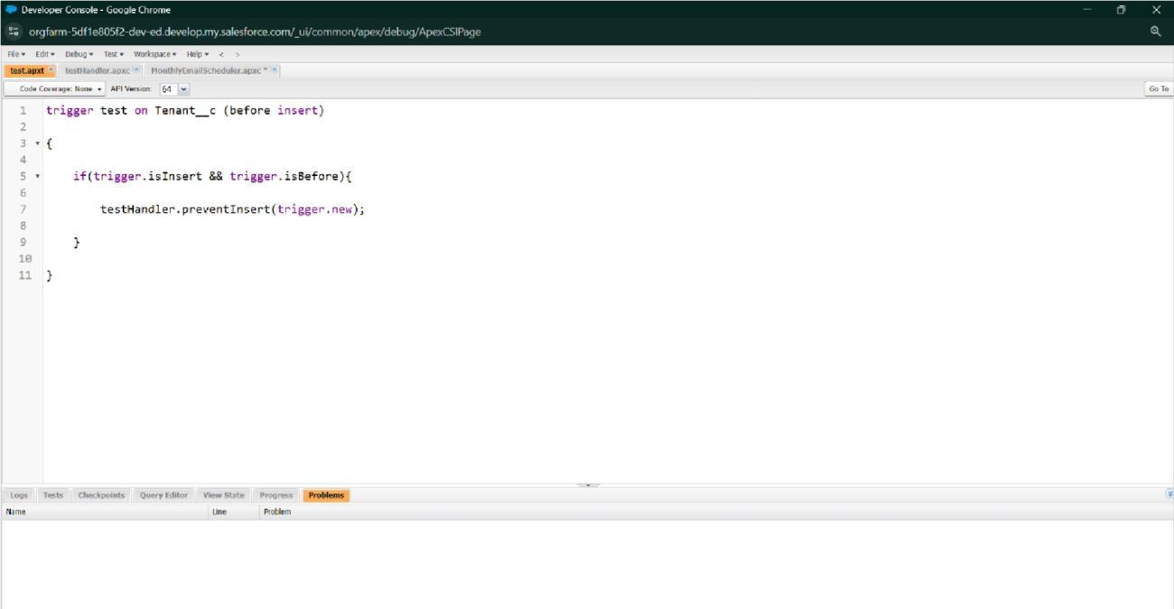

**Create an Apex Handler class**

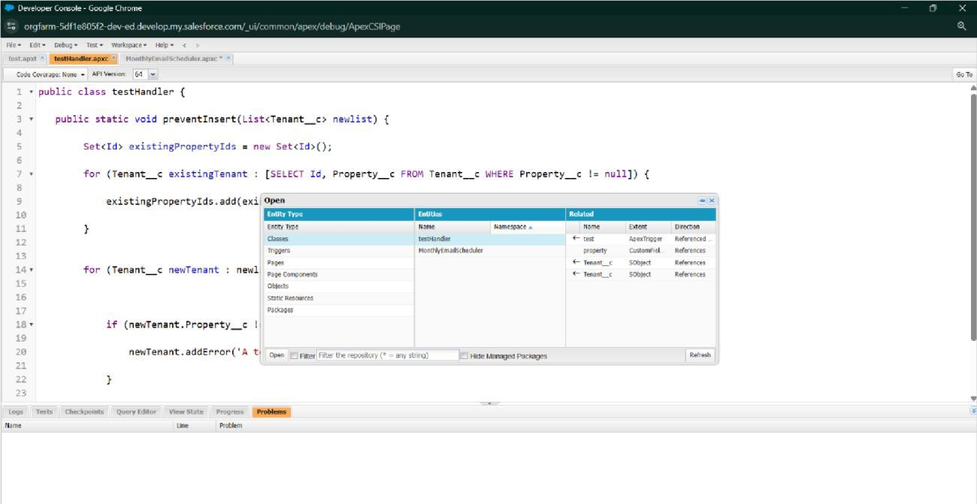

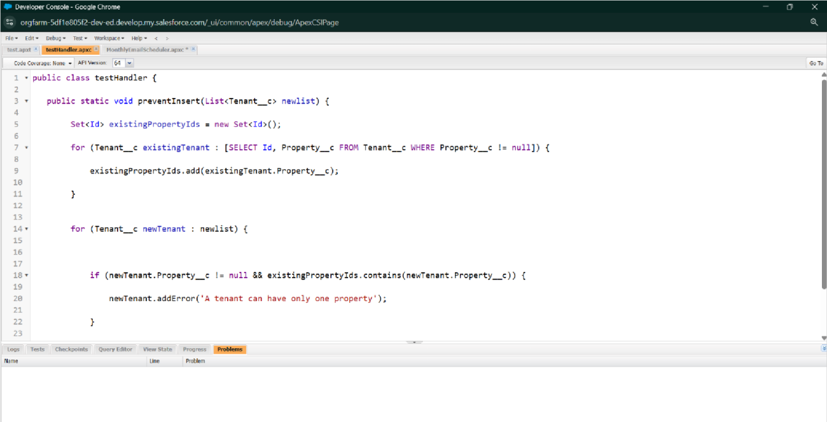

* **FLOWS:** 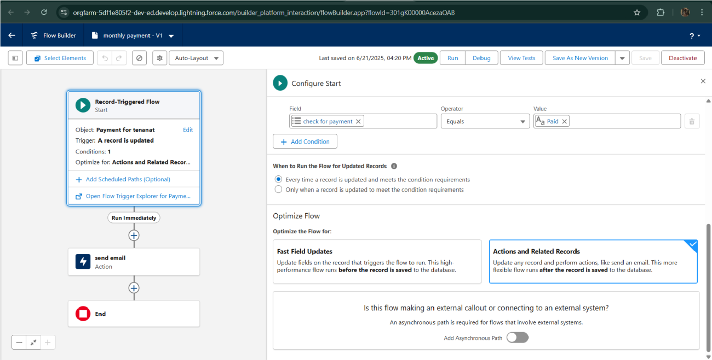

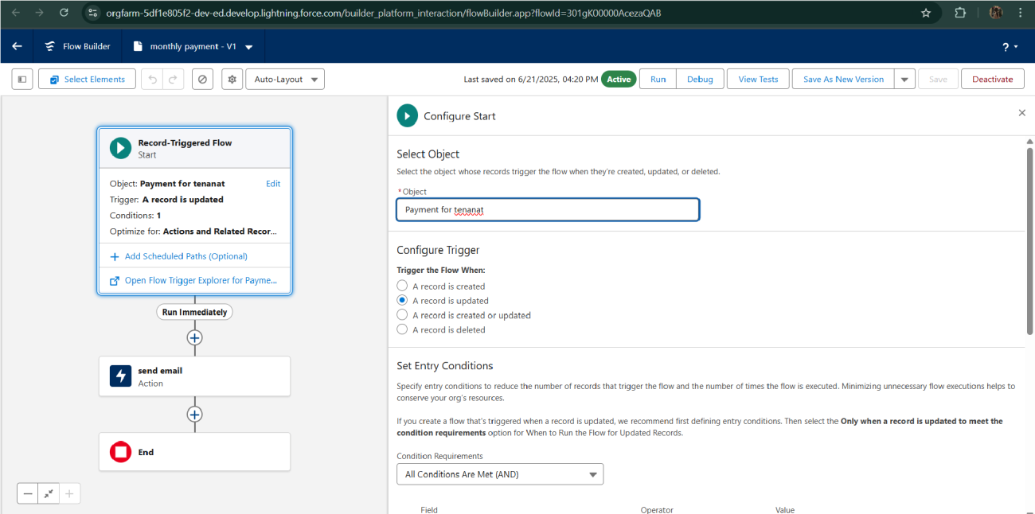

* **Schedule class:**

**Create an Apex Class**

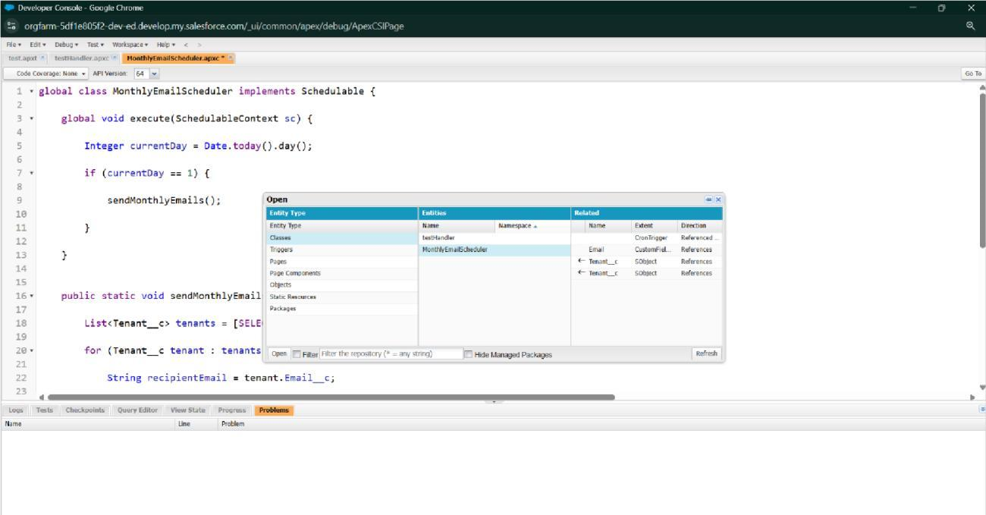

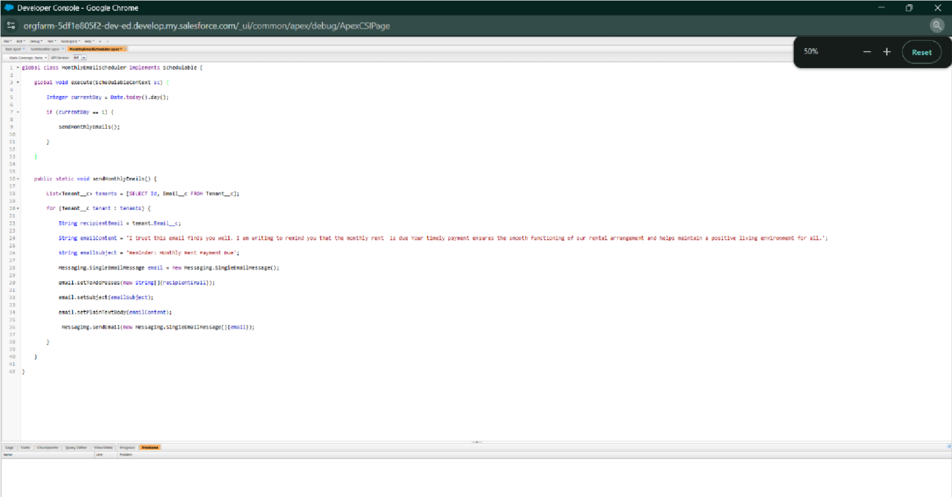

**Schedule Apex class**

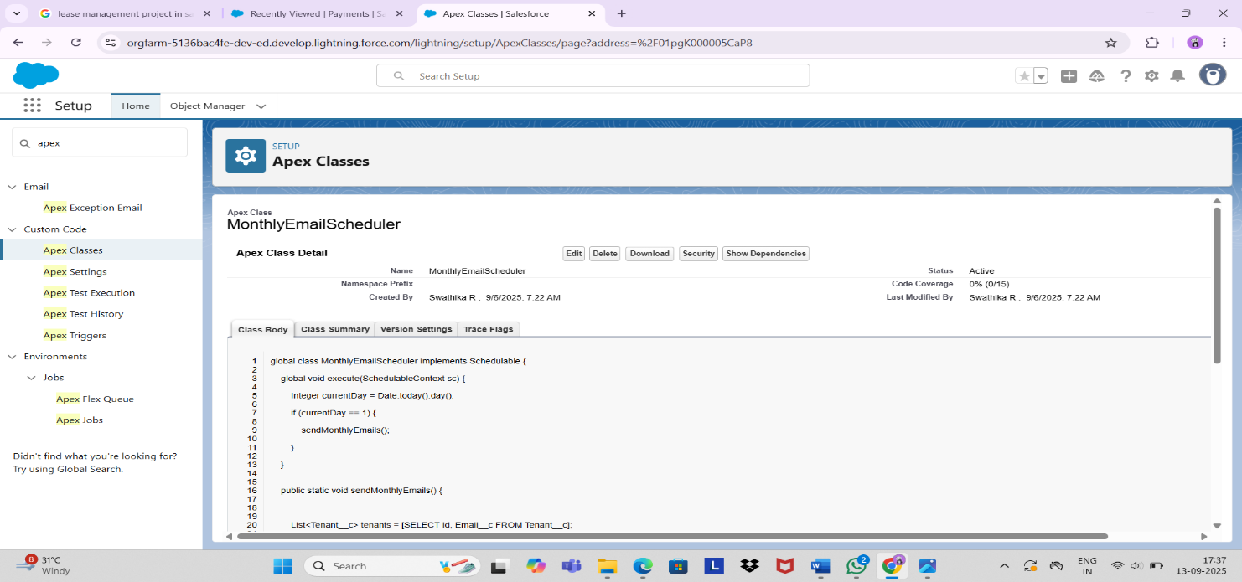

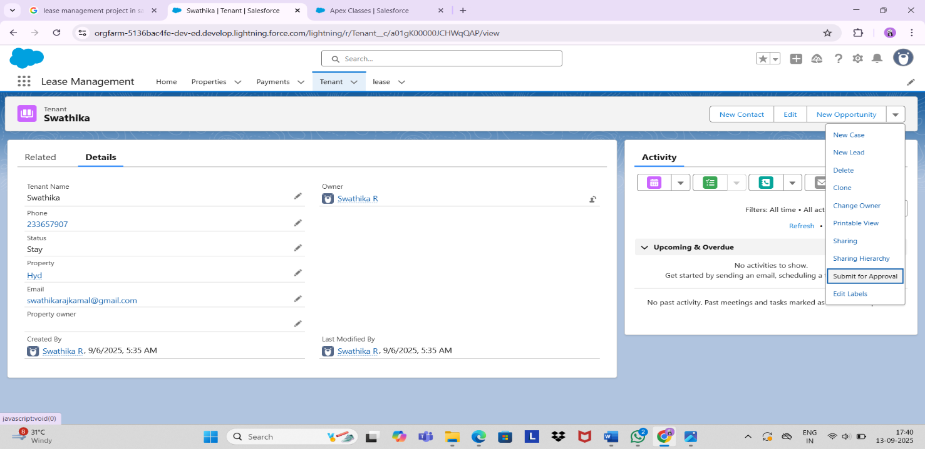

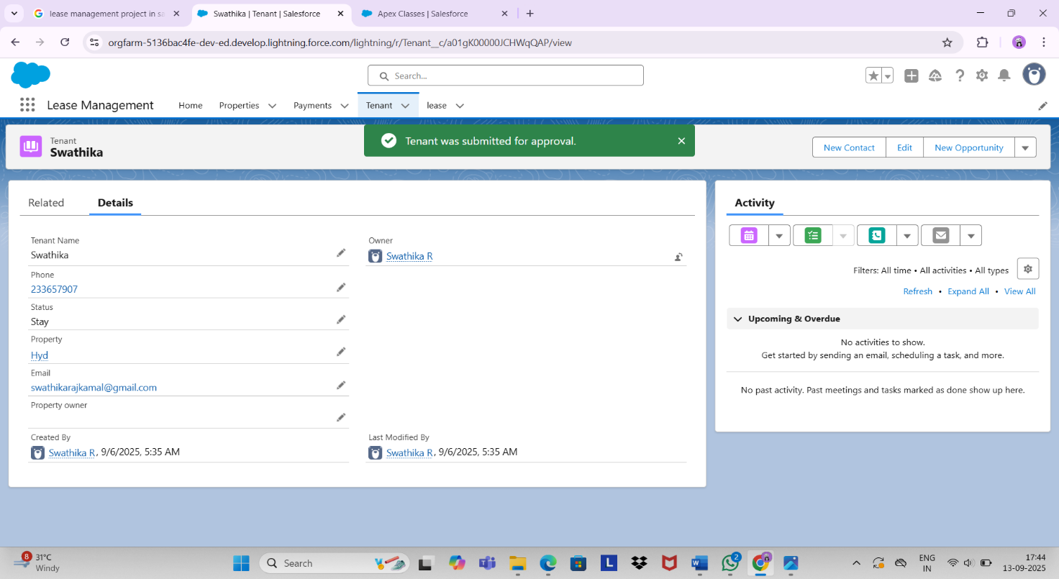

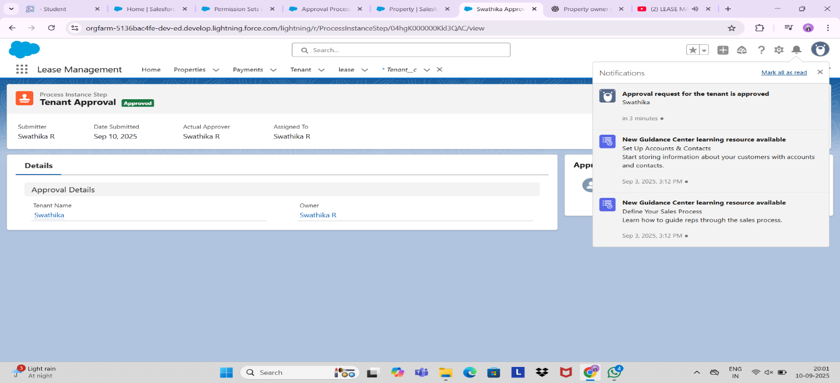

# FUNCTIONAL AND PERFORMANCE TESTING

## Performance Testing

* Trigger validation by entering duplicate tenant-property records

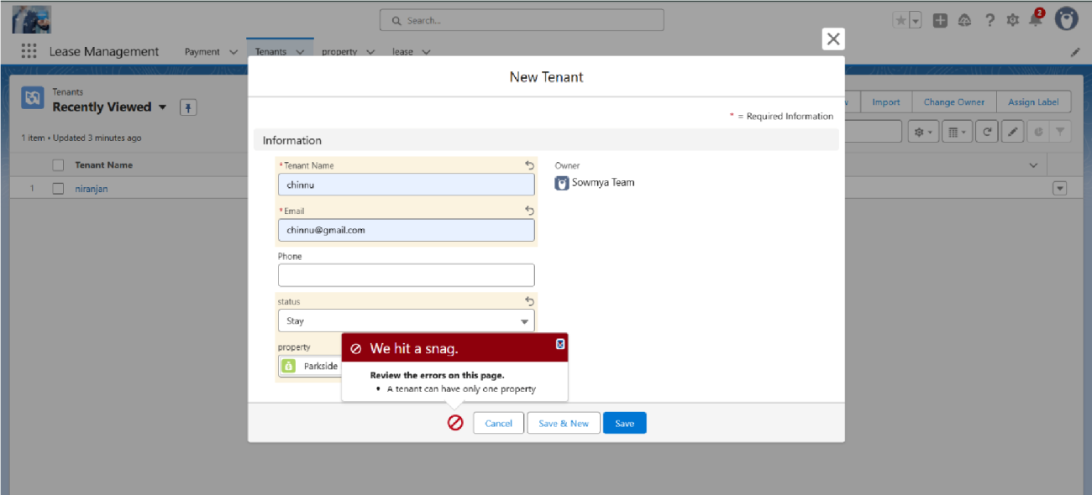

* Validation Rule checking

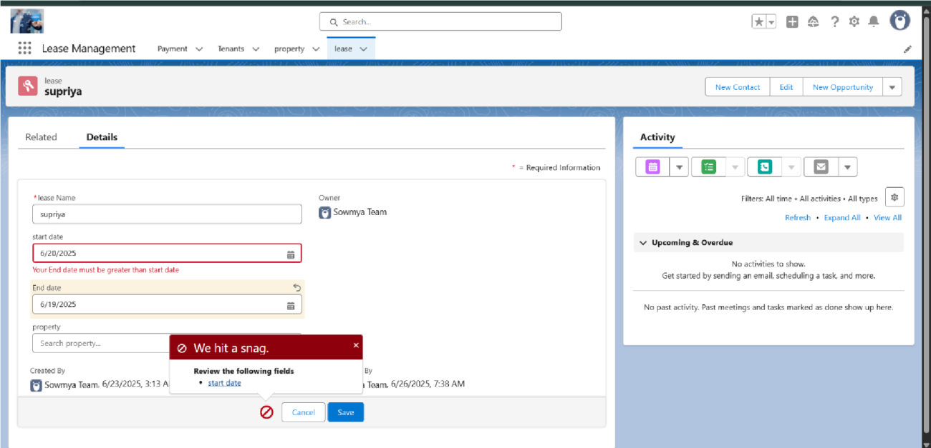

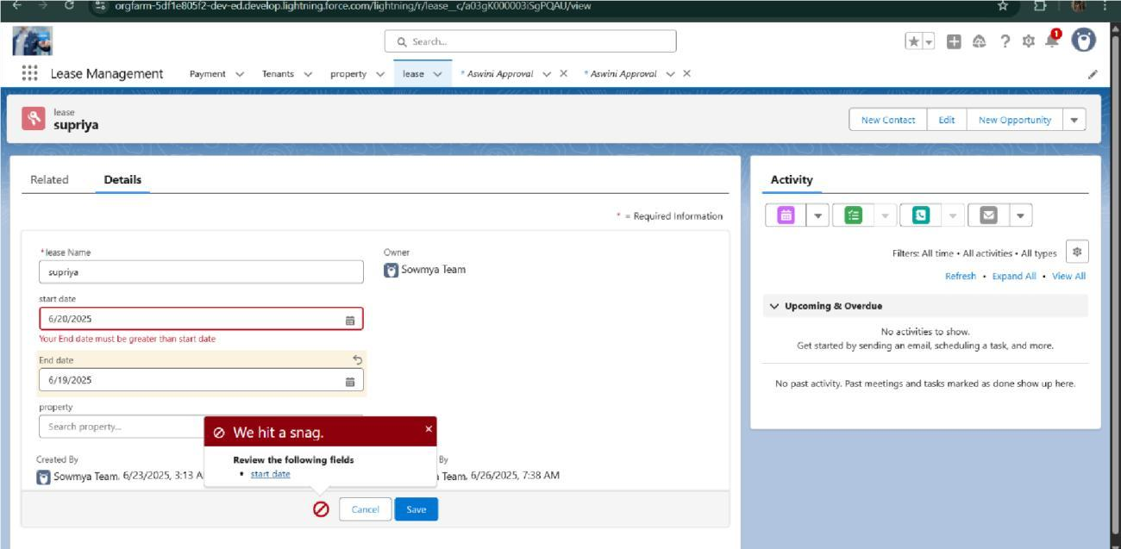

* Test flows on payment update

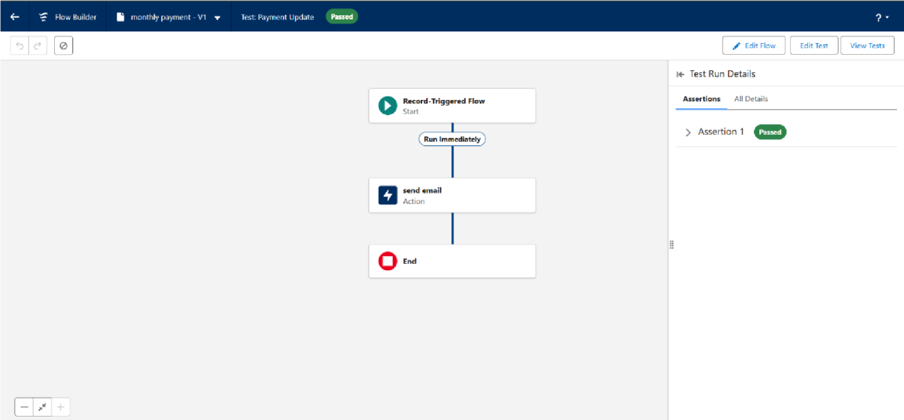

* Approval process validated through email alerts and status updates

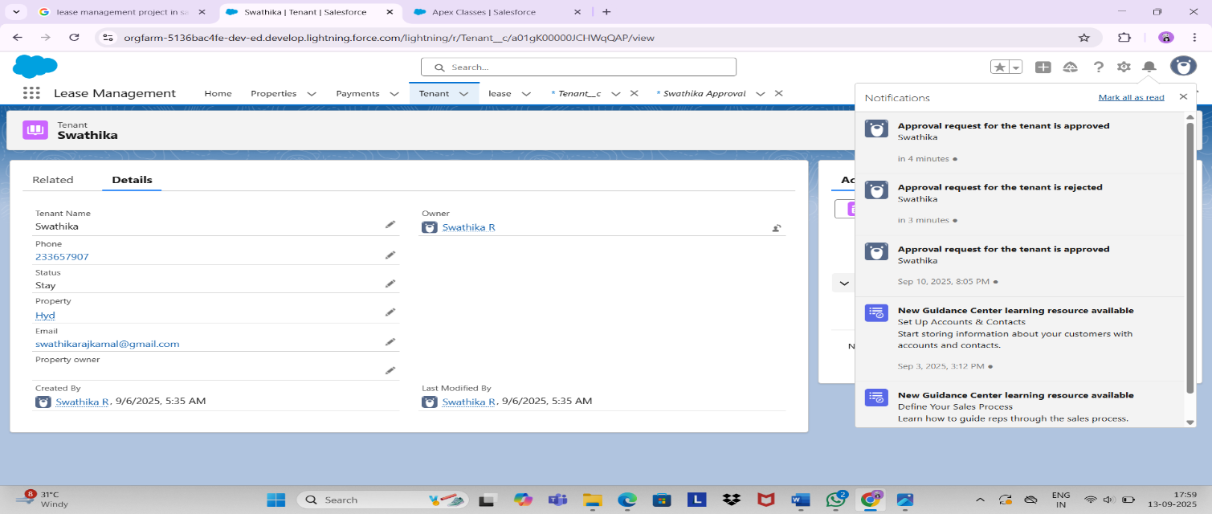

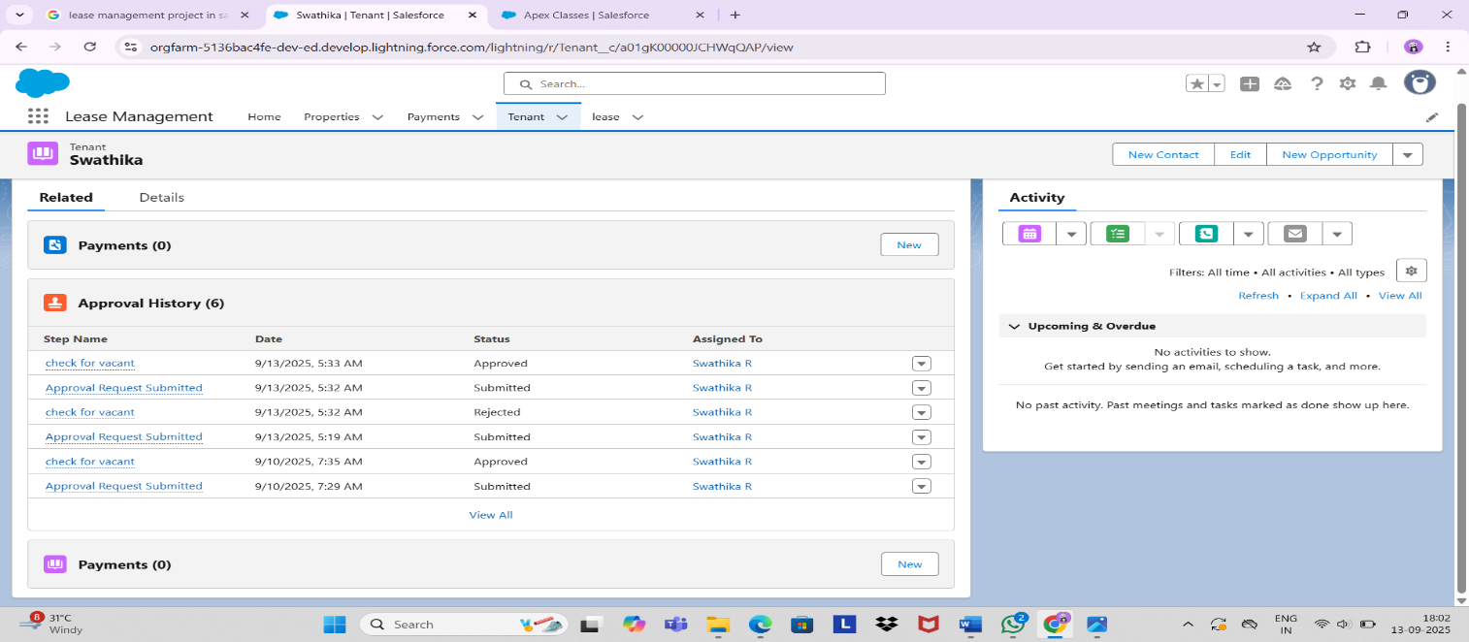

# RESULTS

## Output Screenshots

* Tabs for Property, Tenant, Lease, Payment

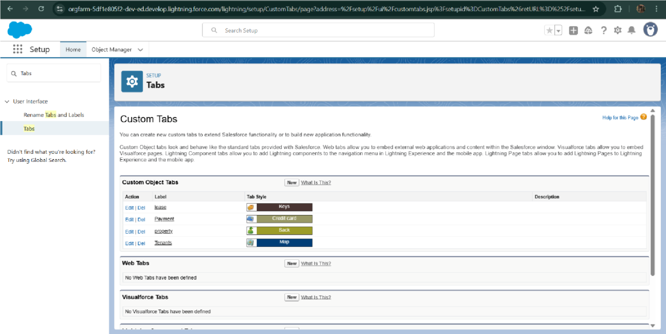

* Email alerts

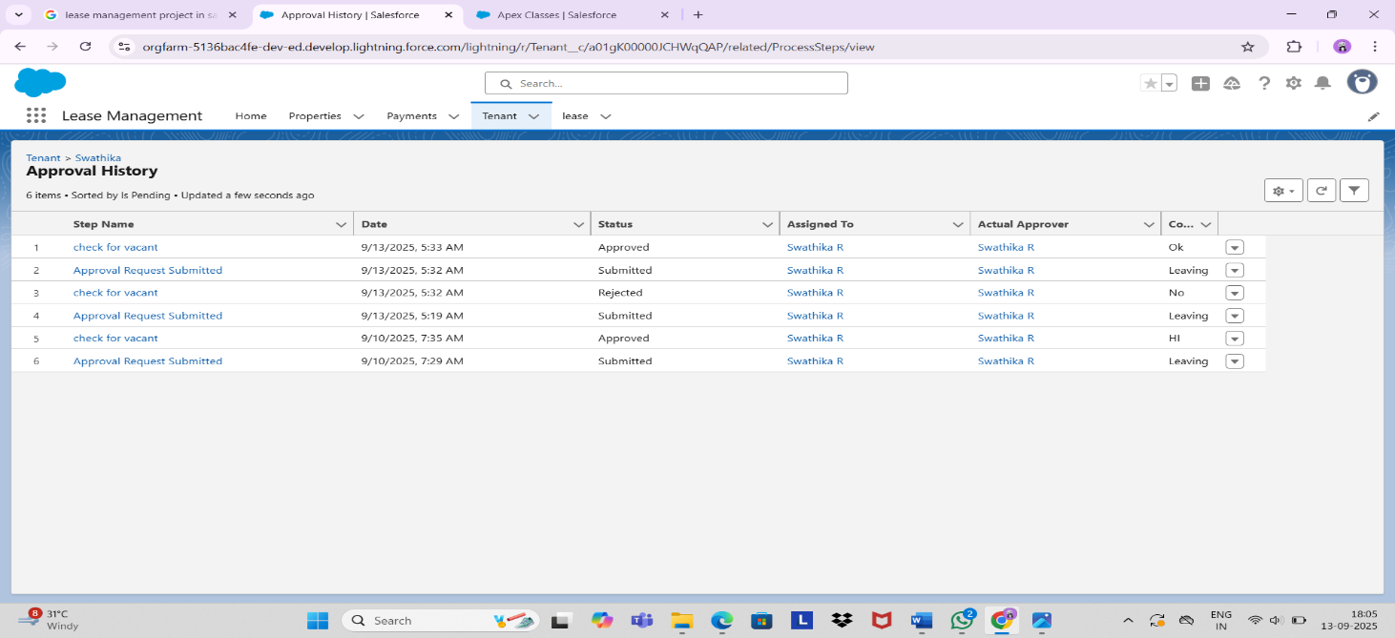

* Request for approve the leave

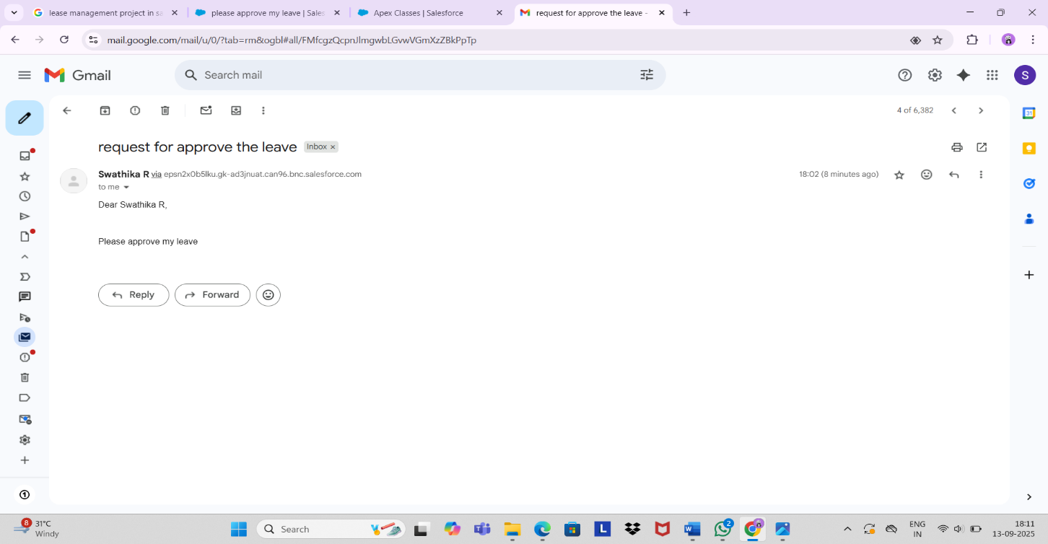

* Leave approved

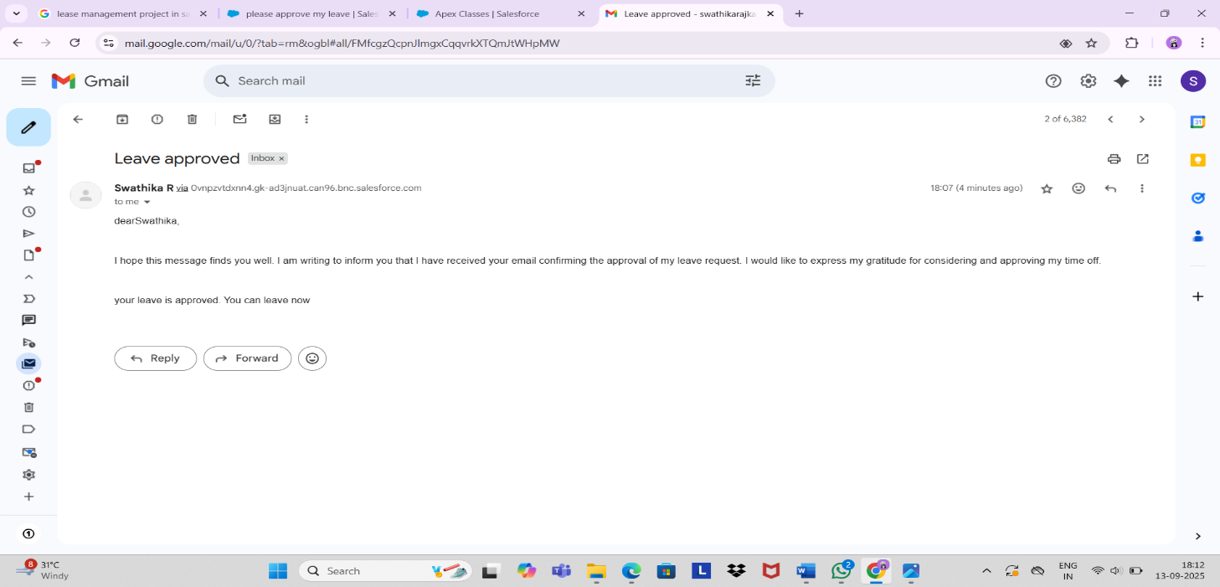

* Leave rejected

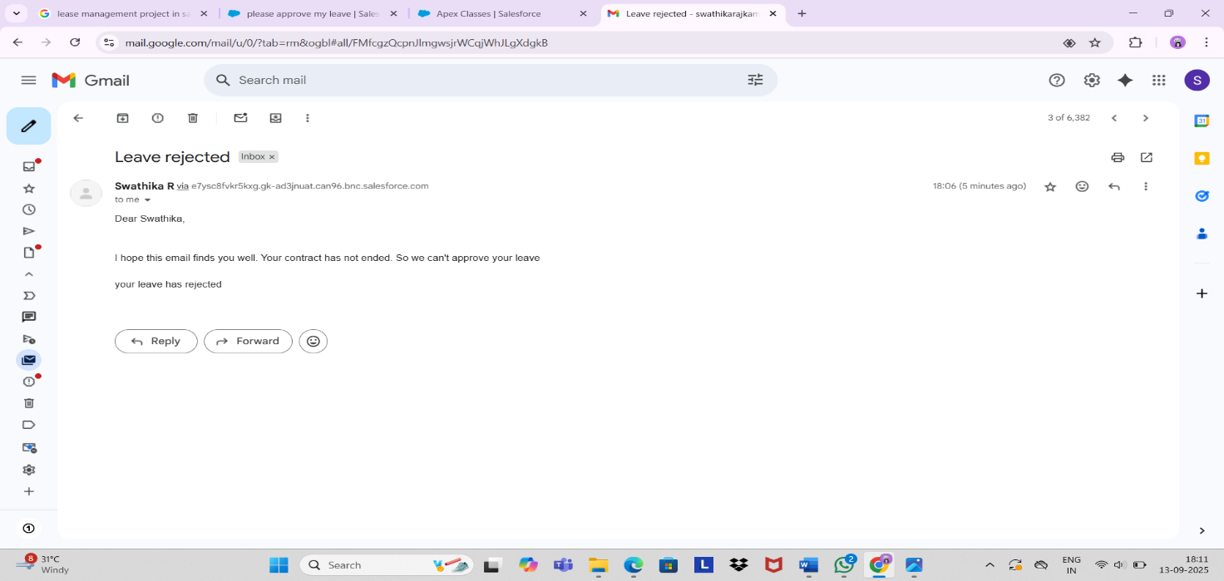

* Flow runs

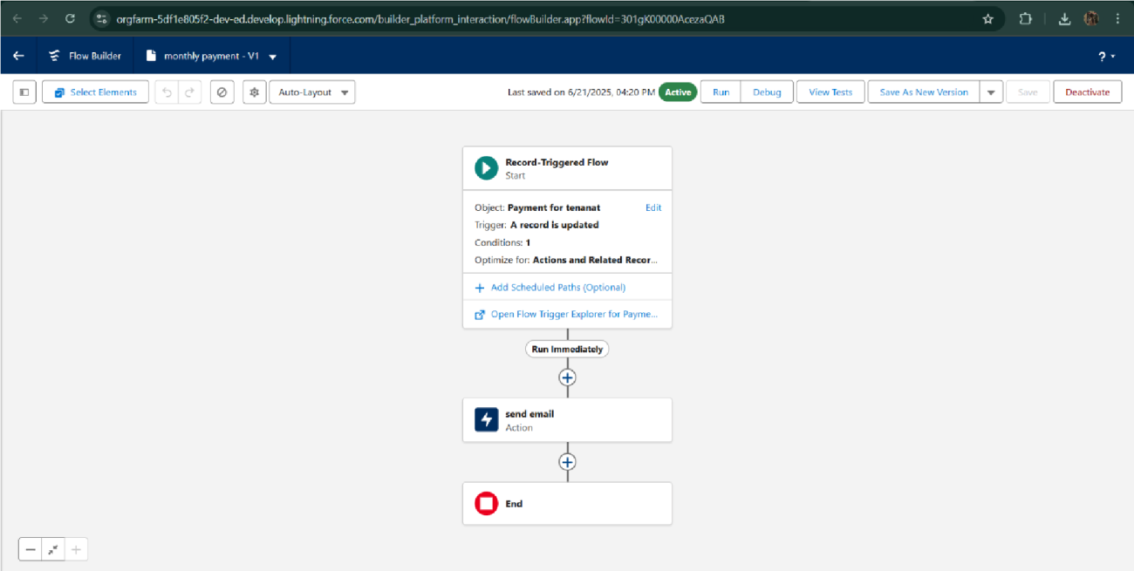

* Trigger error messages

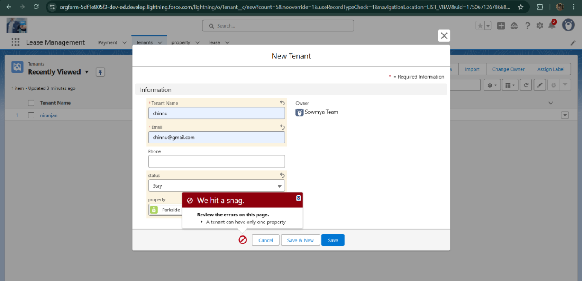

* Approval process notifications

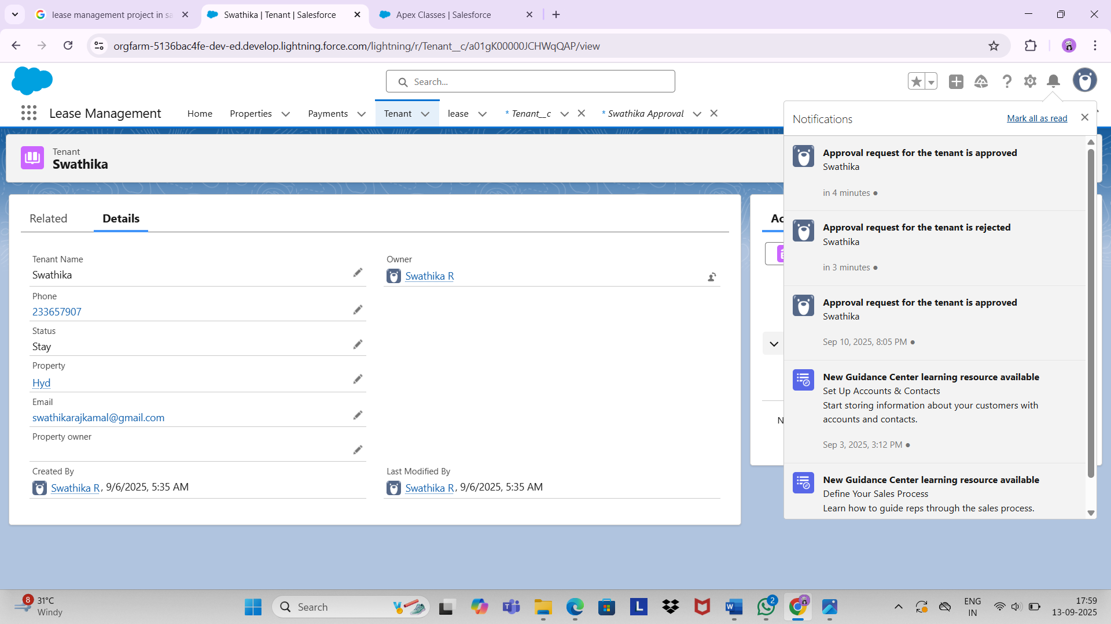

# ADVANTAGES:

# Lower Upfront Costs

# Cash Flow Preservation

* **Asset Upgrade Flexibility**
* **Reduced Risk of Obsolescence**
* **Tax Benefits**
* **Focus on Core Business**

# DISADVANTAGES :

# Higher Total Cost Over Time

# No Ownership or Equity

* **Limited Control**
* **Contractual Penalties**
* **Payment Obligations**
* **Inflexibility**

# CONCLUSION:

This is achieved by leveraging lease management software to automate processes, centralize data, ensure compliance, and provide actionable insights, leading to better relationships with stakeholders, accurate financial reporting, and a stronger competitive position.

## APPENDIX

● **Source Code:** Provided in Apex Classes and Triggers

**Test.apxt:**

trigger test on Tenant__c (before insert)

{

    if(trigger.isInsert && trigger.isBefore){

        testHandler.preventInsert(trigger.new);

    }

}

**TestHandler.apxc:**

public class testHandler {

   public static void preventInsert(List<Tenant__c> newlist) {

        Set<Id> existingPropertyIds = new Set<Id>();

        for (Tenant__c existingTenant : [SELECT Id, Property__c FROM Tenant__c WHERE Property__c != null]) {

            existingPropertyIds.add(existingTenant.Property__c);

        }

        for (Tenant__c newTenant : newlist) {

            if (newTenant.Property__c != null && existingPropertyIds.contains(newTenant.Property__c)) {

                newTenant.addError('A tenant can have only one property');

            }

        }

    }

}

}

**MonthlyEmailScheduler.apxc:**

global class MonthlyEmailScheduler implements Schedulable {

    global void execute(SchedulableContext sc) {

        Integer currentDay = Date.today().day();

        if (currentDay == 1) {

            sendMonthlyEmails();

        }

    }

    public static void sendMonthlyEmails() {

        List<Tenant__c> tenants = [SELECT Id, Email__c FROM Tenant__c];

        for (Tenant__c tenant : tenants) {

            String recipientEmail = tenant.Email__c;

            String emailContent = 'I trust this email finds you well. I am writing to remind you that the monthly rent  is due Your timely payment ensures the smooth functioning of our rental arrangement and helps maintain a positive living environment for all.';

            String emailSubject = 'Reminder: Monthly Rent Payment Due';

            Messaging.SingleEmailMessage email = new Messaging.SingleEmailMessage();

            email.setToAddresses(new String[]{recipientEmail});

            email.setSubject(emailSubject);

            email.setPlainTextBody(emailContent);

             Messaging.sendEmail(new Messaging.SingleEmailMessage[]{email});

        }

    }

}

**THANK YOU**